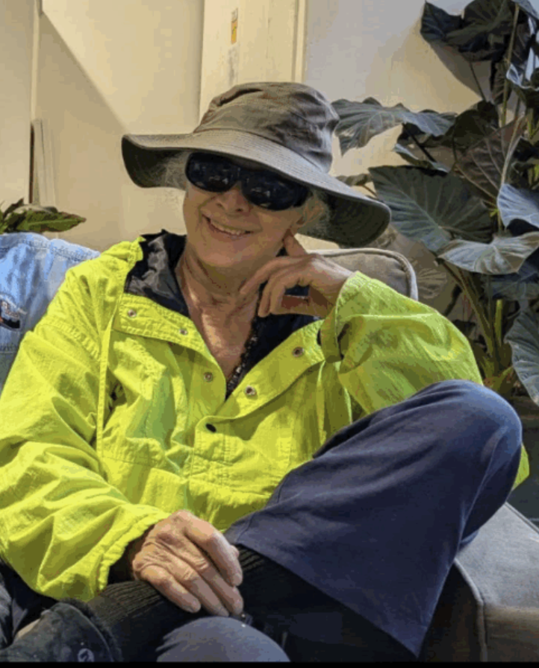

Mary Lyn (Sherwood) Weinberg, 78, of Marlborough, died Wednesday, February 11, 2026.
She was the daughter of the late Laurence and Mary Louise (Sauer) Sherwood and wife of the late Jonathan Weinberg.
Mary is survived by her siblings, Larry Sherwood, Susan Sherwood, John Sherwood and David Sherwood.
Lyn was proud of her beautiful, historic home in Marlborough, that she purchased when it was in terrible disrepair and renovated. Lyn’s ‘pups’, Libby, Leyla and Lily, were the love of her life.
Lyn was an active member of the Quaker Meeting House and gave of her time, talents and energy to maintaining their property.
Lyn was proud of being the first female police officer in Marlborough.
Lyn and Lily enjoyed walking with the Northborough Senior group.
Lyn enjoyed participating in events with the Mass Miata Club.
Lyn enjoyed playing her bass and being in a band with Jon.
Lyn enjoyed singing bass in a women’s barbershop chorus, Women of Note.
Lyn enjoyed scuba diving trips with Jon.
Lyn’s memorial services will be at Framingham Meeting House 841 Edmands Rd. Framingham Ma. 01701
Starts at 10:00 A.M.

