DICK LYONS’ OBITUARY
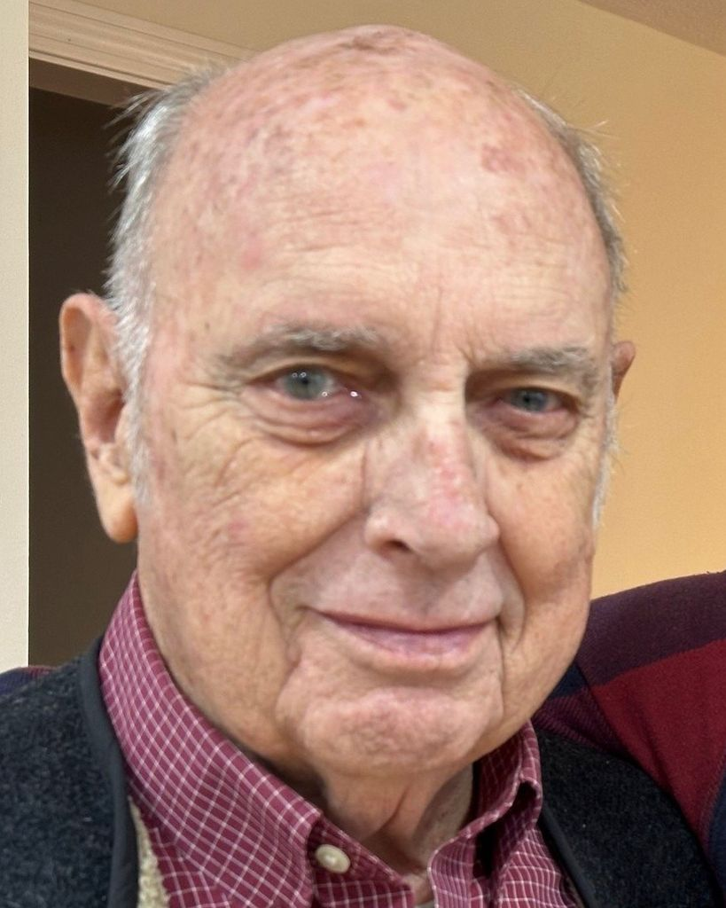
1941Richard2026

Richard F. Lyons
April 22, 1941 — May 10, 2026
Littleton, Massachusetts

Richard “Dick” F. Lyons, 85, a long-time resident of Littleton, passed away peacefully at home on May 10, 2026 after a long battle with stomach cancer. He is survived by his devoted wife of 58 years, Jane Lyons, sister Barbara Enos and brother-in-law Robert Enos of Centerville, MA, his daughter Karen Serna and son-in-law Luis Serna of Austin, TX; his son, Thomas Lyons and daughter-in-law Stephanie Lyons of Littleton and his beloved grandchildren, Lilian, Konnor, Emily, and Samuel.
Dick was born on April 22, 1941, and grew up in Marlborough, Massachusetts, the son of Helen (Gibbons) Lyons and Robert F. Lyons. He graduated from Lowell Technological Institute in 1963 with a degree in physics and earned a Master of Education from Worcester State College in 1969.
Dick taught at Marlborough High School for three years before spending 37 years teaching physics and chemistry at Groton-Dunstable Regional High School. He and Jane married in 1967 after meeting on an outing with the Appalachian Mountain Club. Together they shared a lifelong love of the outdoors, including backpacking trips in the White Mountains of New Hampshire and summers at a remote family camp built by Jane’s father on Middle Saranac Lake in the Adirondacks of New York.
Dick was a lifelong learner and teacher whose curiosity and enthusiasm carried through every stage of his life. Early in their marriage, he and Jane were charter members of Littleton's Sixteen Footers Square Dance club and enjoyed many years of square dancing together. He was also a long-time member of the Harvard Sportsman's Club. In 1996 Dick bought his first Miata. He and Jane joined the Mass Miata Club, enjoying many memorable trips over the years with club members to Montreal, Quebec City, Prince Edward Island, Nova Scotia, and North Carolina. He earned his ham radio license after retiring, proudly operating as W1LTN and becoming an active member of the Nashoba Valley Radio Club and the Police Amateur Radio Team. He also enjoyed many seasons kayaking with Littleton's Prime Time Paddlers.
Dick cared deeply about his community and always willing to give his time to others. He volunteered for many years with the Boy Scouts, Loaves & Fishes Food Pantry, and at The Congregational Church of Littleton, where he served for many years on the property committee.
In lieu of flowers, contributions in Dick’s memory may be made to the steeple fund at The Congregational Church of Littleton (ccol.org) or to Loaves & Fishes Food Pantry, Devens, MA (loavesfishespantry.org).
A celebration of Dick’s life will be held on Saturday, June 13, 2026, at 11:00 A.M. at the Congregational Church of Littleton, 330 King Street, Littleton, MA 01460.
Arrangements are under the care of Badger Funeral Home, A Life Celebration Home, 347 King St., Littleton, MA 01460. 978-486-3709

