May 31, 2026 Dave Comeau's Visiting Hours
David R. Comeau
August 25, 1946 — April 15, 2025
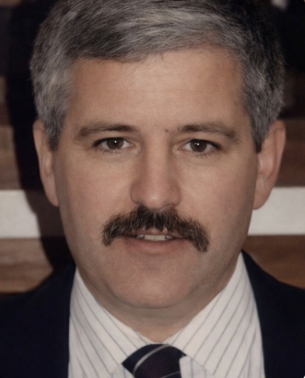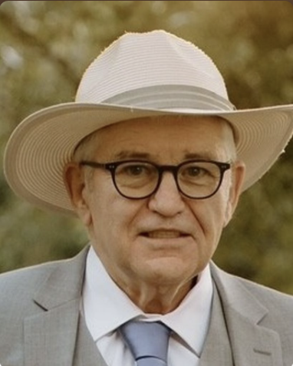

WORCESTER - David Raymond Comeau, a beloved husband, father, grandfather, uncle, neighbor, and friend, passed away peacefully on April 15, 2025, at the age of 78 in Worcester, Massachusetts. Born on August 25, 1946, in Haverhill, Massachusetts, David lived a life marked by intelligence, uniqueness, and a delightful quirkiness that endeared him to all who knew him.
David was the son of J. Norman Comeau and Alma (Boiselle) Comeau. He shared a loving marriage with his wife, Helen Comeau, whom he wed on June 12, 1971, in Iowa. He was a devoted father to his daughter, Jill Marie Comeau and her husband Randy Broxson, and a cherished grandfather to Nicole and Logan. David was also a brother to Claire, Peter, and Phillip. His life took shape from many significant family members and close friends. He was preceded in death by his wife Helen, his parents, and sister Claire Bond.
A man of intellect and skill, David graduated from Haverhill High School in 1964 and went on to earn an associate's degree in mechanical engineering from Wentworth Institute of Technology in Boston. His career as a mechanical engineer in the plastics and business sectors highlighted his sharp mind, culminating in his role as the owner of Albright Technologies, where his innovative spirit thrived.
David's community involvement reflected his generous spirit, with active participation in events such as the Sterling Town Fair and volunteer work with students in robotics through Nypro with US First that left a lasting impact. His personal life was filled with joy, from his hobbies of traveling, Miata Club activities, pottery, and tending to his beloved fruit trees. His special talents for humor and pranks brought laughter to those around him. He found solace swimming in the chilly waters off the New Hampshire coast and cherished travel adventures with his family.
Relatives and friends are kindly invited to attend visiting hours on May 31, 2026 from 12:00 PM to 2:00 PM at Miles-Sterling Funeral & Tribute Center, 100 Worcester Road in Sterling, followed by a luncheon at the Chocksett Inn at 2:30 PM.
In lieu of flowers, the family kindly requests memorial donations be made to Hospice at Rose Monahan in Worcester, MA (vnacare.org/donors) or McLean Hospital's psychiatric services (giving.mclean.org).
To leave a message or share a memory please visit www.milesfuneralhome.com
To order memorial trees or send flowers to the family in memory of David R. Comeau, please visit our flower store.

