Mass Miata Club ltd

www.massmiata.net Established 1990

MEMBERSHIP APPLICATION ( ) or RENEWAL ( )

Name______________________________________________CoMember:____________________________________

Email 1__________________________________________Email 2__________________________________________

Telephone numbers are not shared

BIRTHDAY: MONTH AND DAY ONLY

Birthday: Month________________Day______Only Birthday: Month________________Day______Only

Name Badges: You ____________________________________CoMemberr__________________________________

Mailing Address___________________________________________________________________________________

City_____________________________________________________________State______Zip_________________

Contact Phone___________________________Cell (Optional)_____________________
Mass Miata Club, ltd will not share you telephone.
I

Maita 1 (Soft Top) (PRHT Power Top) (RF Power Top) (Please circle one)
Principal Driver_________________________________________________
Year:___________________Color:________________Trim___________Trans: 5 SPD 6SPD Auto
Miata 2 (Soft Top) (PRHt Power Top) (RF Power Top) ( Please Circle one)
Principal Driver___________________________________________________
Year:_________________Color:_________________Trim:___________Trans 5 SPD 6SPD AUTO
Please complete the information on the reverse side of this page:
Ver 20181108 ver:2022-07-11

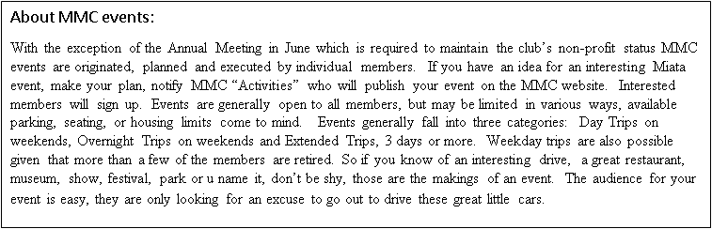
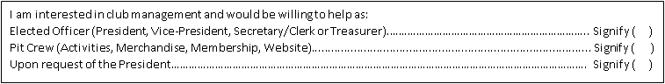
USEFUL FOR MMC DRIVES, A CB RADIO
INEXPENSIVE AND EFFECTIVE IN KEEPING THE GROUP TOGETHER

I found the Mass Miata Club, ltd through:_____________________________________________

X__________________________________________________________Date:_________________
Please enclose a check payable to “MASS MIATA CLUB ltd.”
One year membership @ $30.00, two years @ $45.00 or 5 years @ $90.00
MAIL To: Mass Miata Club, ltd %Janet Baylis, 37 Acorn Ave, Fitchburg MA 01420
Questions? EMAIL MEMBERSHIP@MASSMIATA.NET

The Mass Miata Club Ltd. assumes no liability for any injury or damages to a member resulting from membership in this club. Information collected may be used within the Mass Miata Club for the purpose of notifying members of events and meetings. The information collected will not be sold to or shared with any other organization or business. App20150718 rv 2022-07-11

